Directions: Solve the following inequalities.

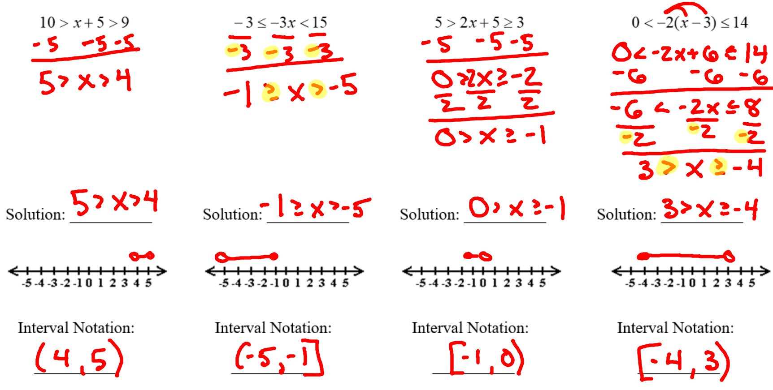

Directions: Solve the following absolute value inequalities.

